Elliptical Closed Shapes
# Source: AI Source: Provided by: [Data Path: Persons Table -> ID Column: 1, Name_En Column: Motasem Essam] -> From: [ChatGPT] on [7/25/2026]
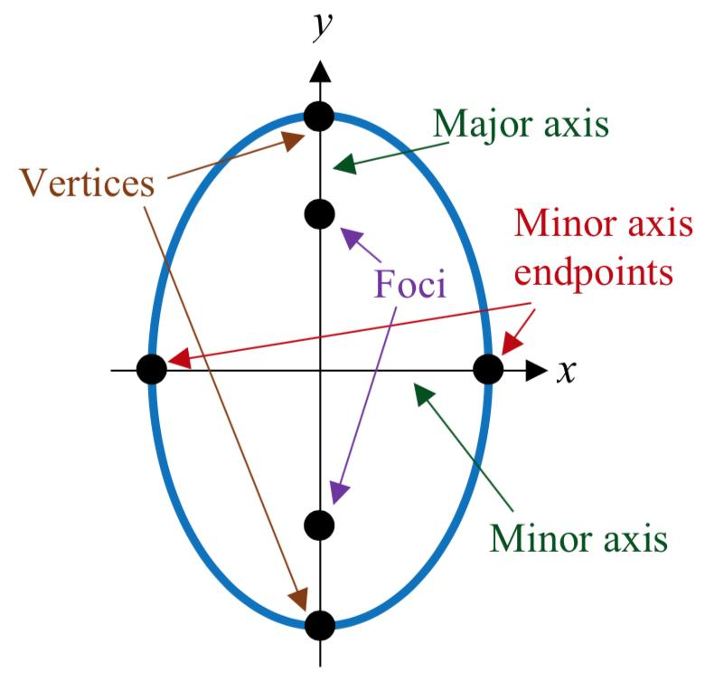
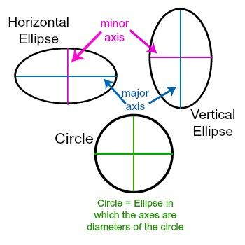
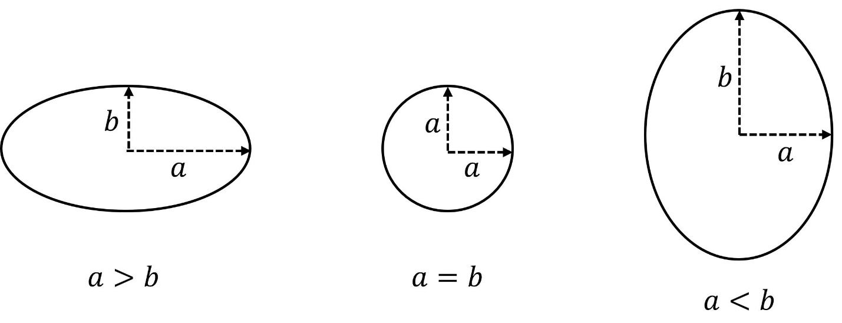
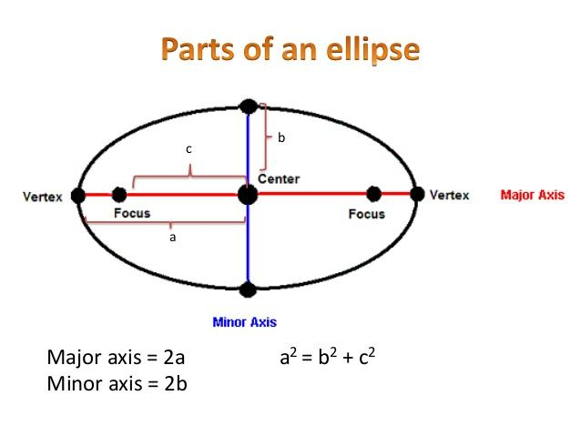

Definition
# Source: AI Source: Provided by: [Data Path: Persons Table -> ID Column: 1, Name_En Column: Motasem Essam] -> From: [ChatGPT] on [7/25/2026]
An Elliptical Closed Shape is a closed curved shape whose boundary follows an ellipse.
An ellipse is the set of points in a plane for which the sum of the distances to two fixed points (the foci) is constant.
$$\boxed{PF_{1}+PF_{2}=2a}$$
An ellipse is a closed curve, so its boundary returns continuously to its starting point and encloses a bounded region.
$$\boxed{\text{Elliptical Closed Shape}=\text{Closed}+\text{Curved}+\text{Elliptical Boundary}}$$

Characteristics
# Source: AI Source: Provided by: [Data Path: Persons Table -> ID Column: 1, Name_En Column: Motasem Essam] -> From: [ChatGPT] on [7/25/2026]
An elliptical closed shape typically has:
- A continuous closed curved boundary.
- No straight sides.
- No vertices.
- A center.
- A major axis.
- A minor axis.
- Two foci.
- Two principal axes of symmetry.
- A bounded interior region.
For a standard ellipse centered at the origin:
$$\boxed{\frac{x^{2}}{a^{2}}+\frac{y^{2}}{b^{2}}=1}$$
where:
- $a$ = semi-major axis when $a>b$
- $b$ = semi-minor axis
- Major axis length $=2a$
- Minor axis length $=2b$

Types of Elliptical Closed Shapes

1. Standard Ellipse
# Source: AI Source: Provided by: [Data Path: Persons Table -> ID Column: 1, Name_En Column: Motasem Essam] -> From: [ChatGPT] on [7/25/2026]
The basic elliptical closed shape with two perpendicular axes.
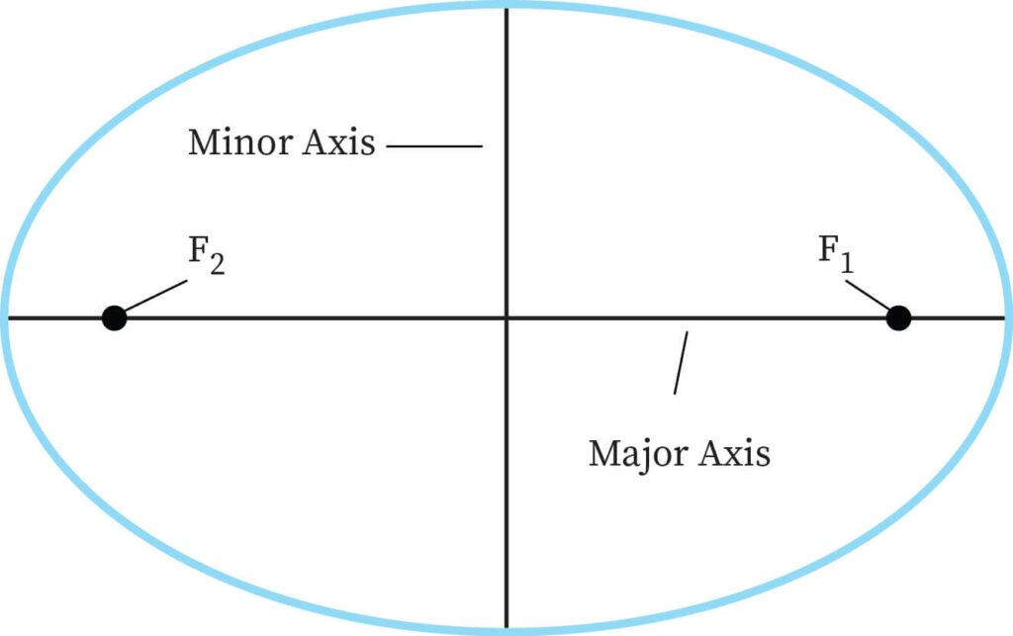
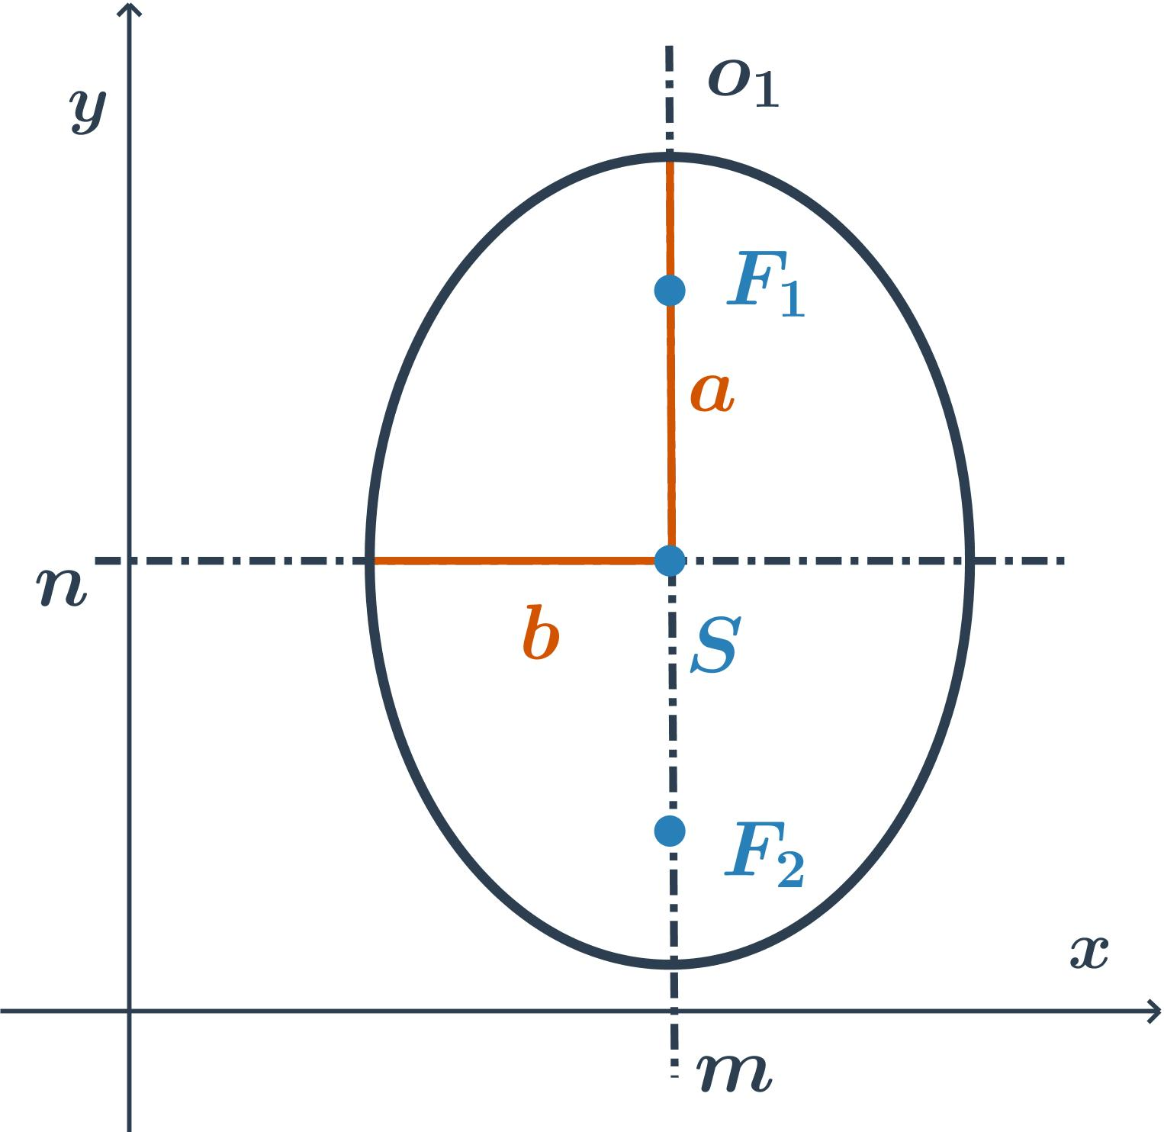
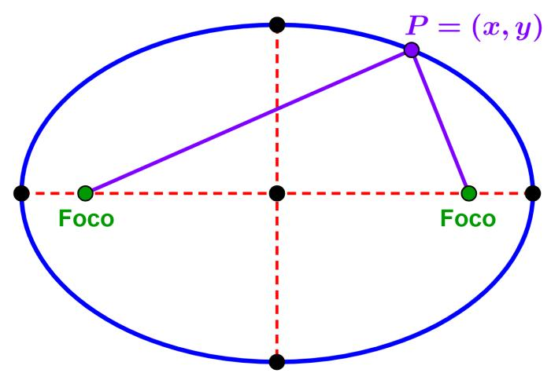
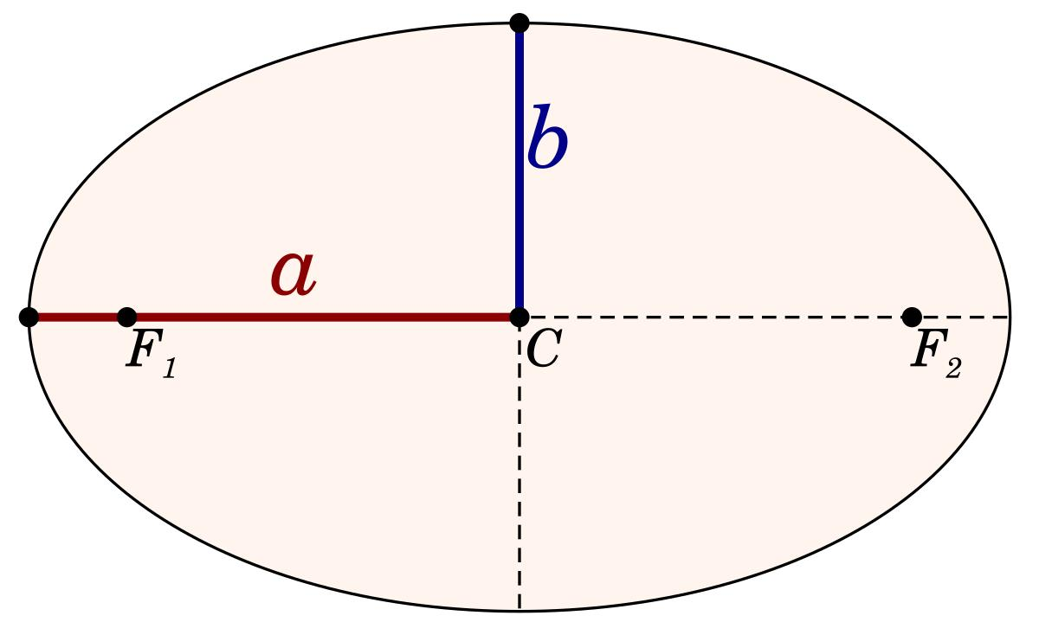
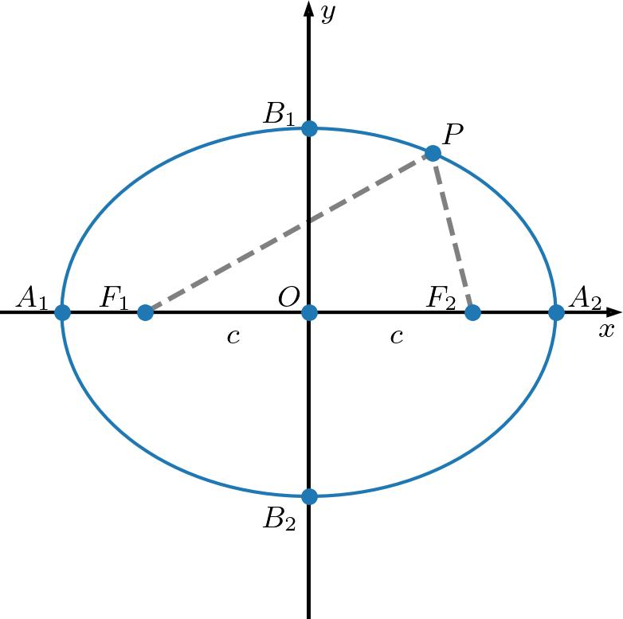
For a horizontal ellipse:
$$\boxed{\frac{{\left(x-h\right)}^{2}}{a^{2}}+\frac{{\left(y-k\right)}^{2}}{b^{2}}=1}$$
with $a>b$.

2. Horizontal Ellipse
# Source: AI Source: Provided by: [Data Path: Persons Table -> ID Column: 1, Name_En Column: Motasem Essam] -> From: [ChatGPT] on [7/25/2026]
An ellipse whose major axis is horizontal.
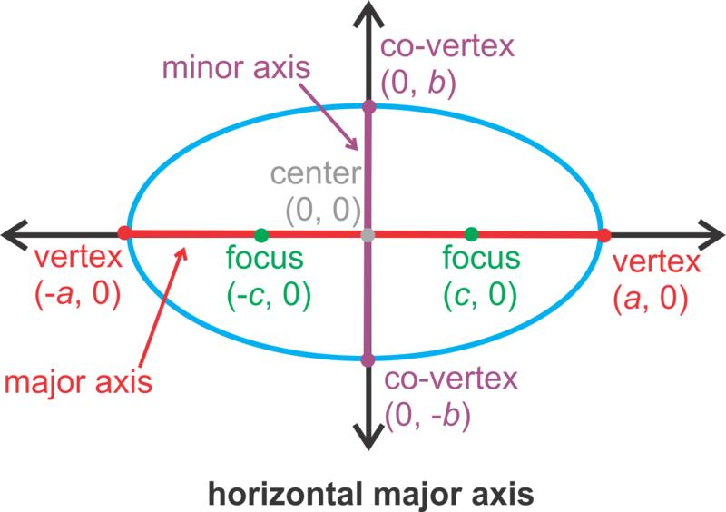
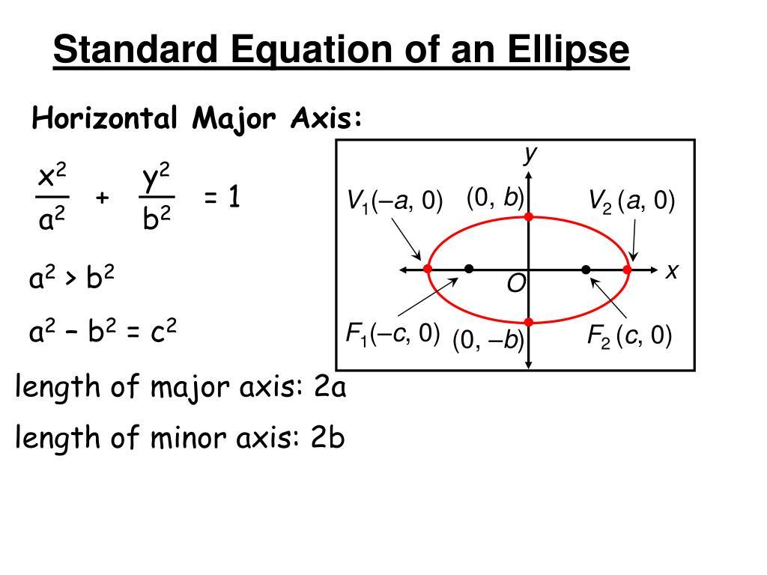
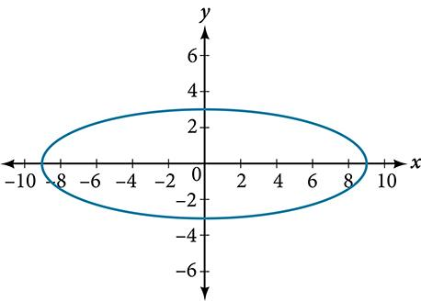
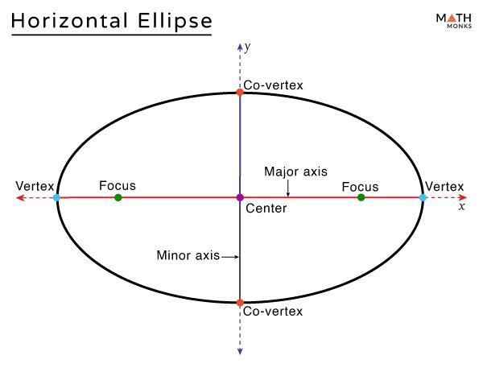
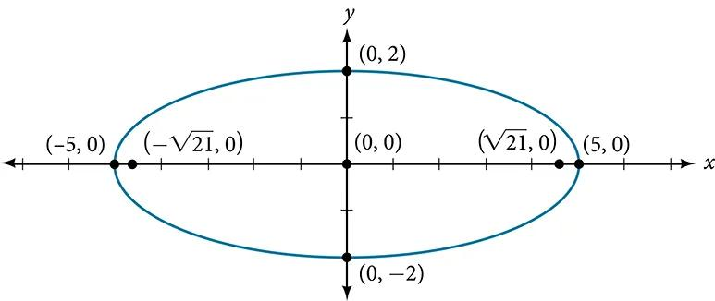
Its major-axis direction is:
$$\boxed{\text{Horizontal}}$$
The standard form is:
$$\boxed{\frac{{\left(x-h\right)}^{2}}{a^{2}}+\frac{{\left(y-k\right)}^{2}}{b^{2}}=1, a>b}$$

3. Vertical Ellipse
# Source: AI Source: Provided by: [Data Path: Persons Table -> ID Column: 1, Name_En Column: Motasem Essam] -> From: [ChatGPT] on [7/25/2026]
An ellipse whose major axis is vertical.
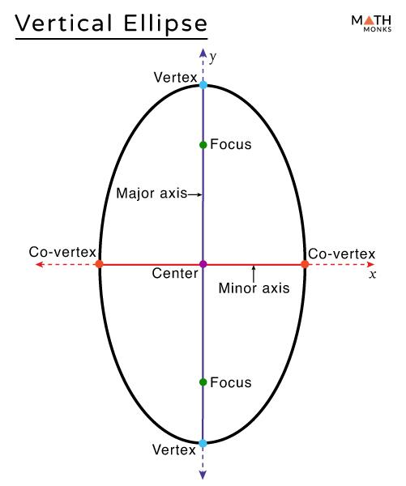
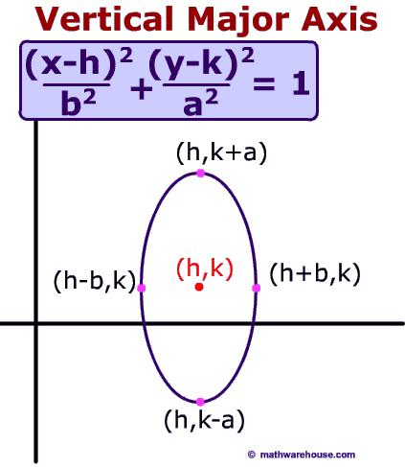
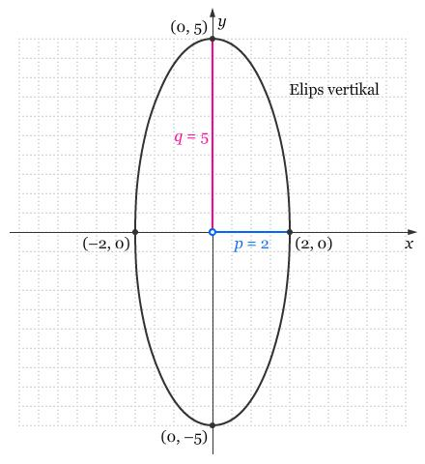
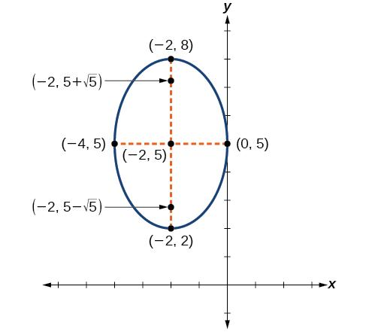
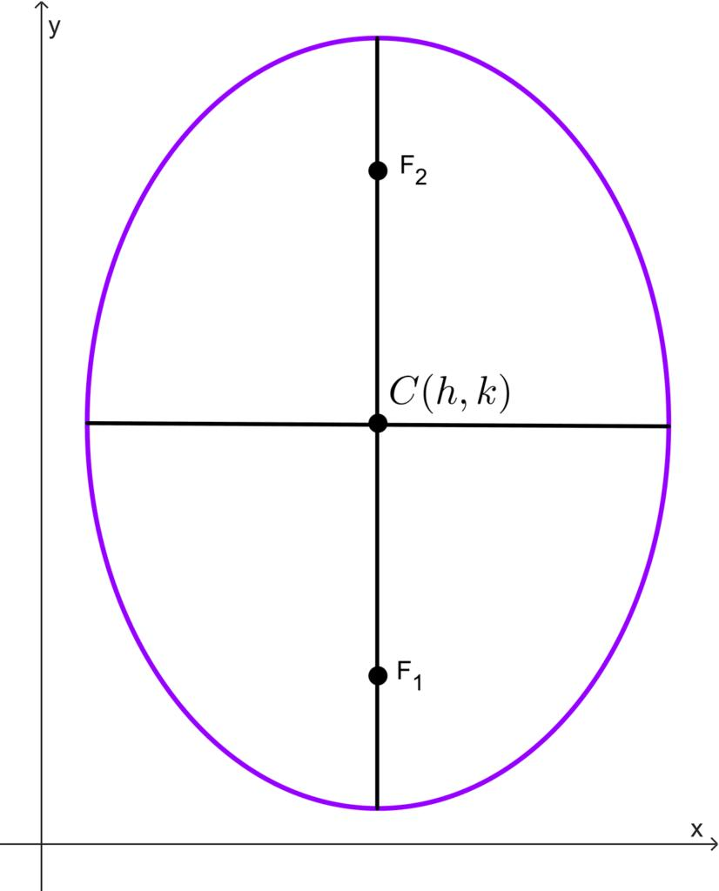
Its major-axis direction is:
$$\boxed{\text{Vertical}}$$
The larger denominator is associated with the $y$-term:
$$\boxed{\frac{{\left(x-h\right)}^{2}}{b^{2}}+\frac{{\left(y-k\right)}^{2}}{a^{2}}=1, a>b}$$

4. Rotated Ellipse
# Source: AI Source: Provided by: [Data Path: Persons Table -> ID Column: 1, Name_En Column: Motasem Essam] -> From: [ChatGPT] on [7/25/2026]
An ellipse whose major and minor axes are not aligned with the horizontal and vertical coordinate axes.
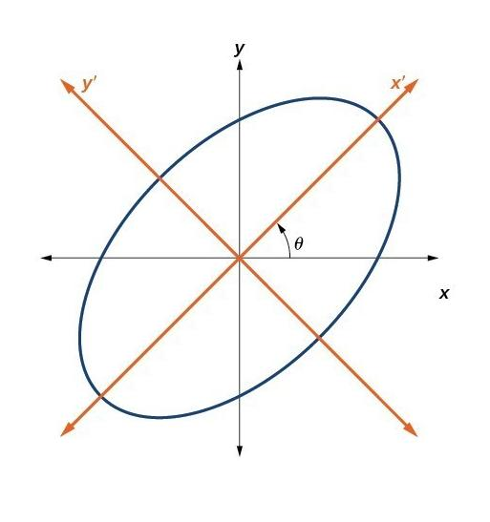
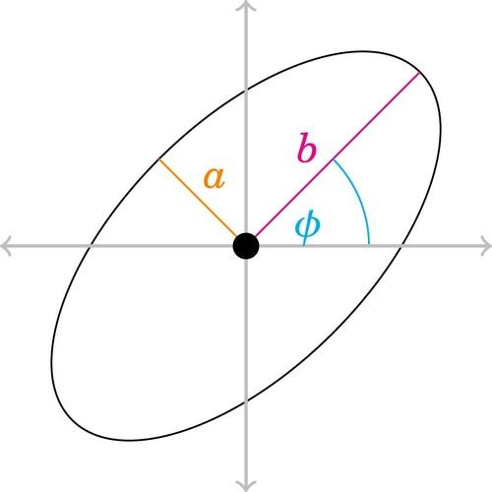
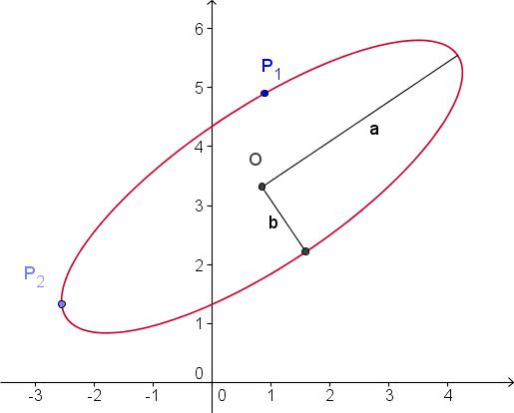
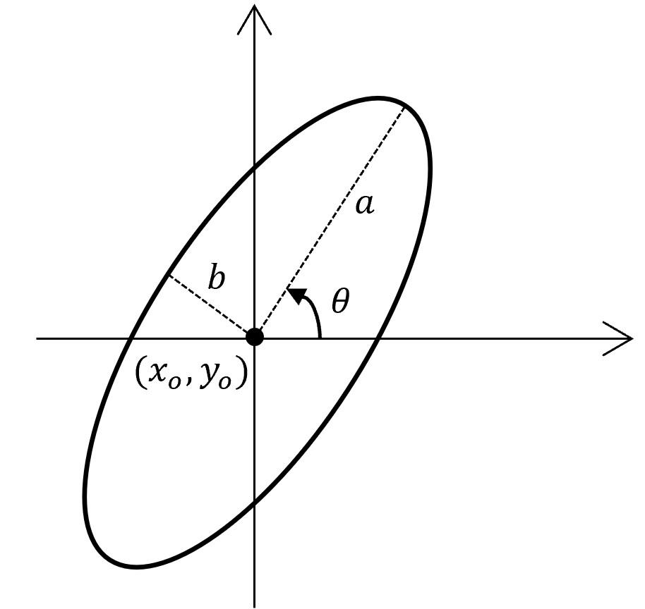
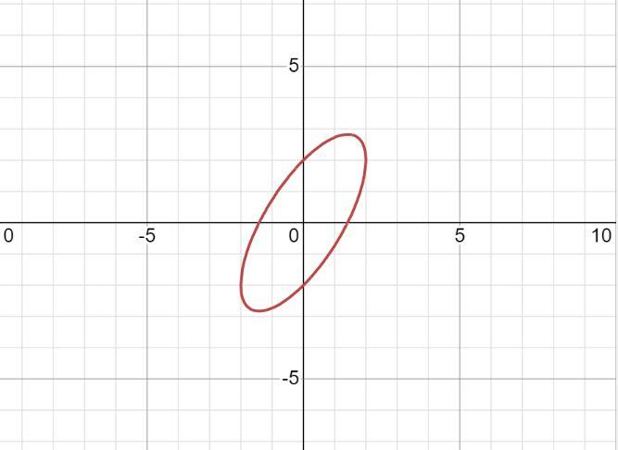
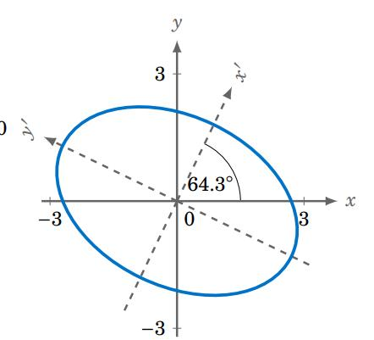
The ellipse remains closed and retains its elliptical geometry, but its axes are rotated.
A rotated ellipse can be represented parametrically as:
$$\boxed{\begin{aligned}x=h+a\cos{t}\cos{θ}-b\sin{t}\sin{θ} \\ y=k+a\cos{t}\sin{θ}+b\sin{t}\cos{θ}\end{aligned}}$$

5. Circular Ellipse
# Source: AI Source: Provided by: [Data Path: Persons Table -> ID Column: 1, Name_En Column: Motasem Essam] -> From: [ChatGPT] on [7/25/2026]
When the two semi-axes are equal:
$$a=b$$
the ellipse becomes a circle.
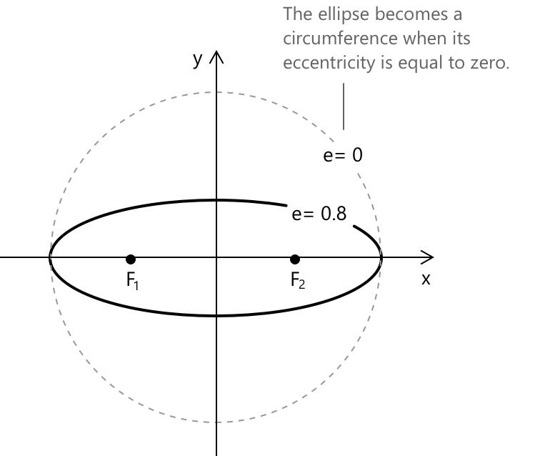
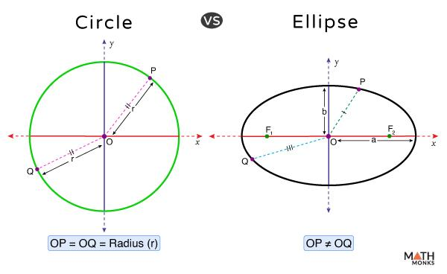
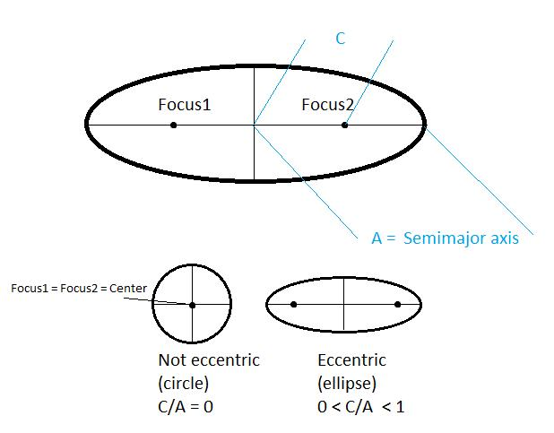
Therefore:
$$\boxed{a=b⇒\text{Circle}}$$
This is an important mathematical relationship because a circle is a special case of an ellipse.

6. Elliptical Ring
# Source: AI Source: Provided by: [Data Path: Persons Table -> ID Column: 1, Name_En Column: Motasem Essam] -> From: [ChatGPT] on [7/25/2026]
An elliptical ring is the region between two nested ellipses.
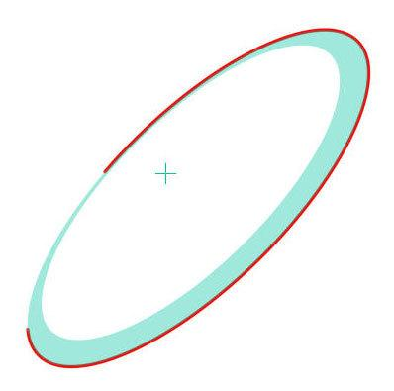
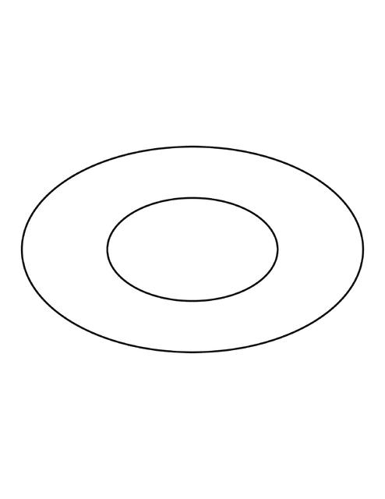
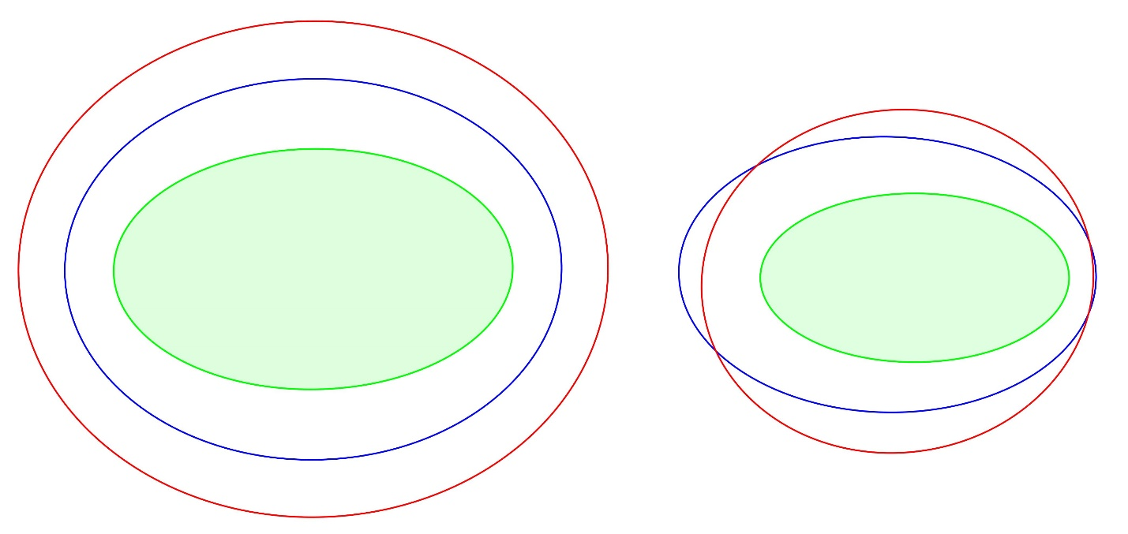
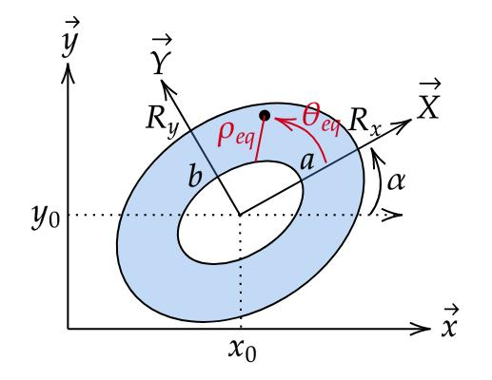
It has:
- An outer elliptical boundary.
- An inner elliptical boundary.
- A closed ring-shaped region.
If the ellipses have the same center and orientation, the area is:
$$\boxed{A=π\left(a_{1}b_{1}-a_{2}b_{2}\right)}$$

7. Concentric Elliptical Shapes
# Source: AI Source: Provided by: [Data Path: Persons Table -> ID Column: 1, Name_En Column: Motasem Essam] -> From: [ChatGPT] on [7/25/2026]
Several ellipses can share the same center.
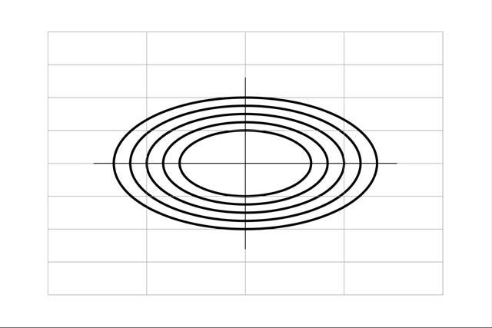
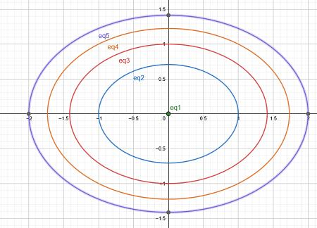
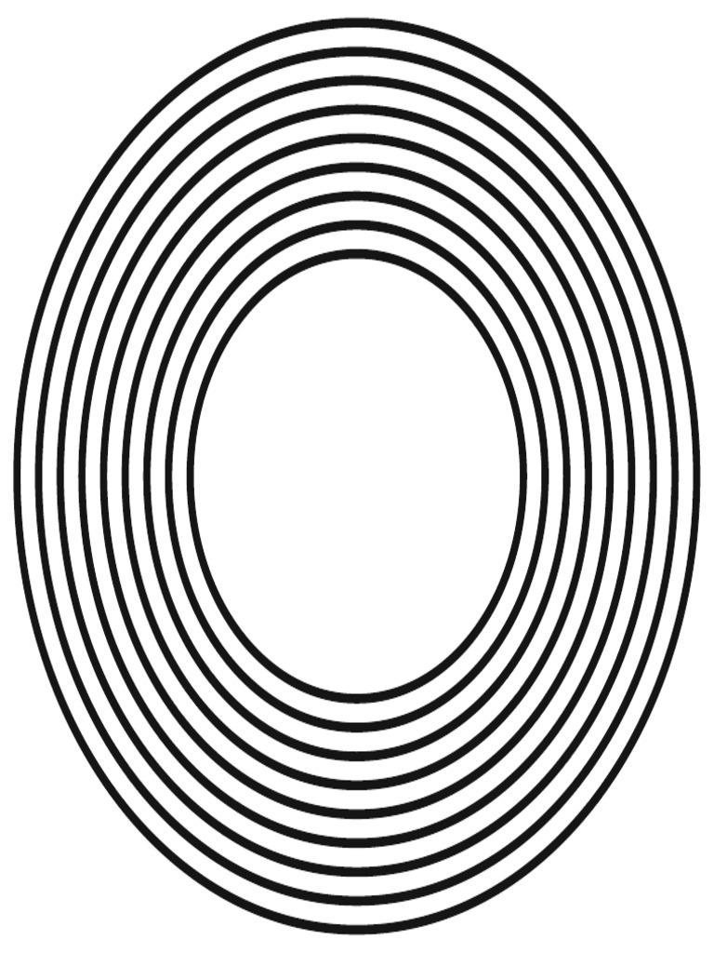
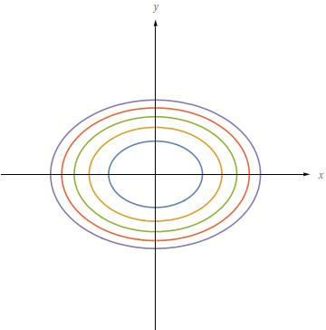
They may form multiple elliptical regions or rings.
$$\boxed{C_{1}=C_{2}=C_{3}=⋯}$$
where all ellipses share the same center.

8. Irregular-Looking Elliptical Closed Shapes
# Source: AI Source: Provided by: [Data Path: Persons Table -> ID Column: 1, Name_En Column: Motasem Essam] -> From: [ChatGPT] on [7/25/2026]
Some elliptical forms may appear irregular because they are:
- Rotated.
- Highly elongated.
- Very flattened.
- Combined with other elliptical boundaries.
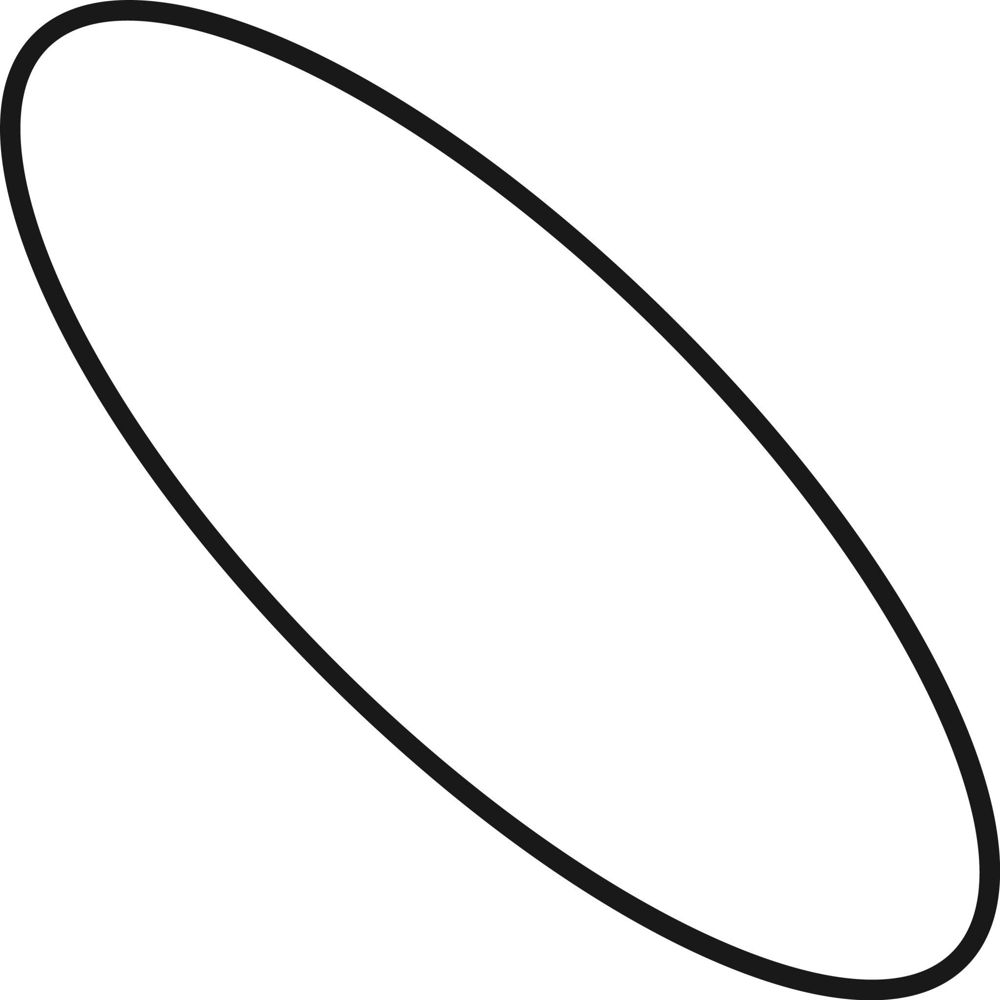
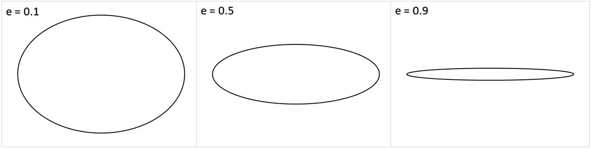
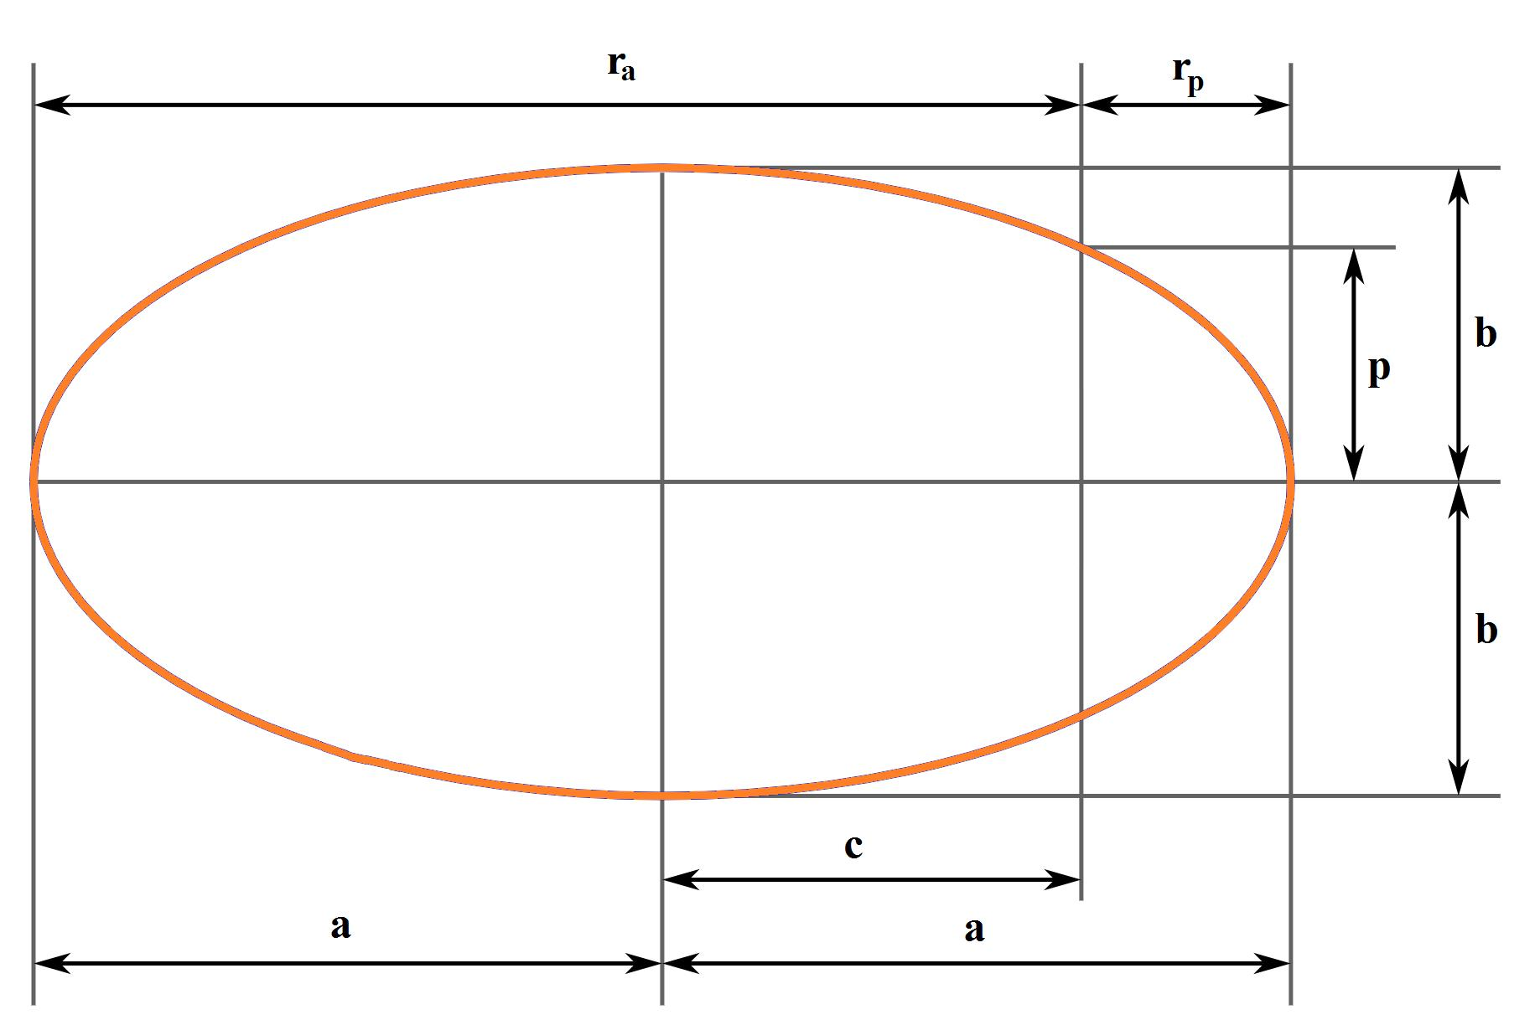
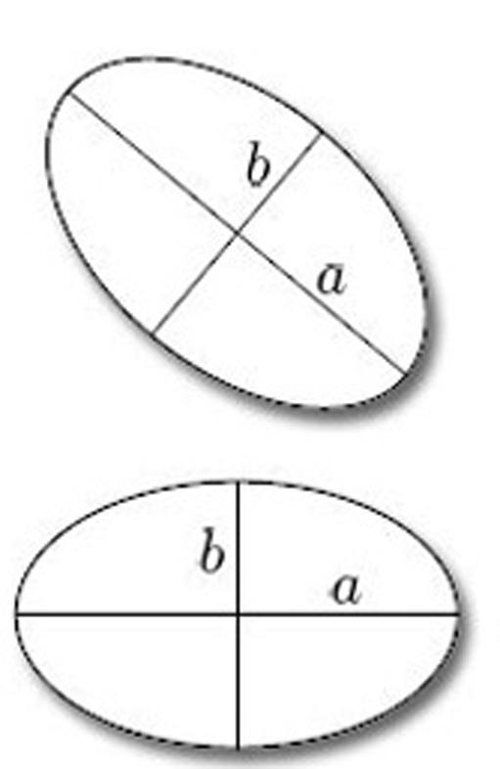
However, an actual ellipse remains mathematically regular in its defining structure even if it looks unusual.

Area
# Source: AI Source: Provided by: [Data Path: Persons Table -> ID Column: 1, Name_En Column: Motasem Essam] -> From: [ChatGPT] on [7/25/2026]
The area enclosed by an ellipse is:
$$\boxed{A=πab}$$
where $a$ and $b$ are the semi-major and semi-minor axes.
For example, if:
$$a=6, b=3$$
then:
$$A=π\left(6\right)\left(3\right)=18π$$

Perimeter
# Source: AI Source: Provided by: [Data Path: Persons Table -> ID Column: 1, Name_En Column: Motasem Essam] -> From: [ChatGPT] on [7/25/2026]
Unlike the circle, an ellipse does not have a simple elementary formula for its exact perimeter.
The exact perimeter can be represented using an elliptic integral:
$$\boxed{P=4aE\left(e\right)}$$
where:
$$e=\sqrt{1-\frac{b^{2}}{a^{2}}}$$
is the eccentricity and $E\left(e\right)$ is the complete elliptic integral of the second kind.
For practical calculations, approximations are commonly used.

Symmetry
# Source: AI Source: Provided by: [Data Path: Persons Table -> ID Column: 1, Name_En Column: Motasem Essam] -> From: [ChatGPT] on [7/25/2026]
A standard ellipse has:
1. Horizontal symmetry
Reflection across the major-axis line.
2. Vertical symmetry
Reflection across the minor-axis line.
3. Rotational symmetry
An ellipse has rotational symmetry of (180^\circ) about its center.
$$\boxed{\text{Symmetry Order}=2}$$

Eccentricity
# Source: AI Source: Provided by: [Data Path: Persons Table -> ID Column: 1, Name_En Column: Motasem Essam] -> From: [ChatGPT] on [7/25/2026]
The eccentricity describes how elongated the ellipse is:
$$\boxed{e=\sqrt{1-\frac{b^{2}}{a^{2}}}}$$
For an ellipse:
$$\boxed{0≤e<1}$$
Special case:
$$e=0$$
corresponds to a circle.
As $e$ approaches $1$, the ellipse becomes increasingly elongated.
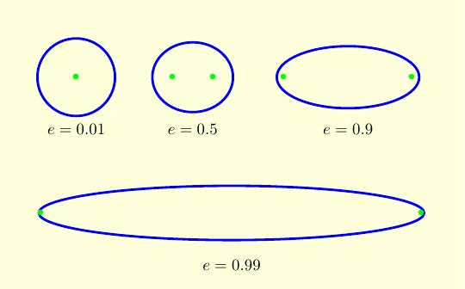
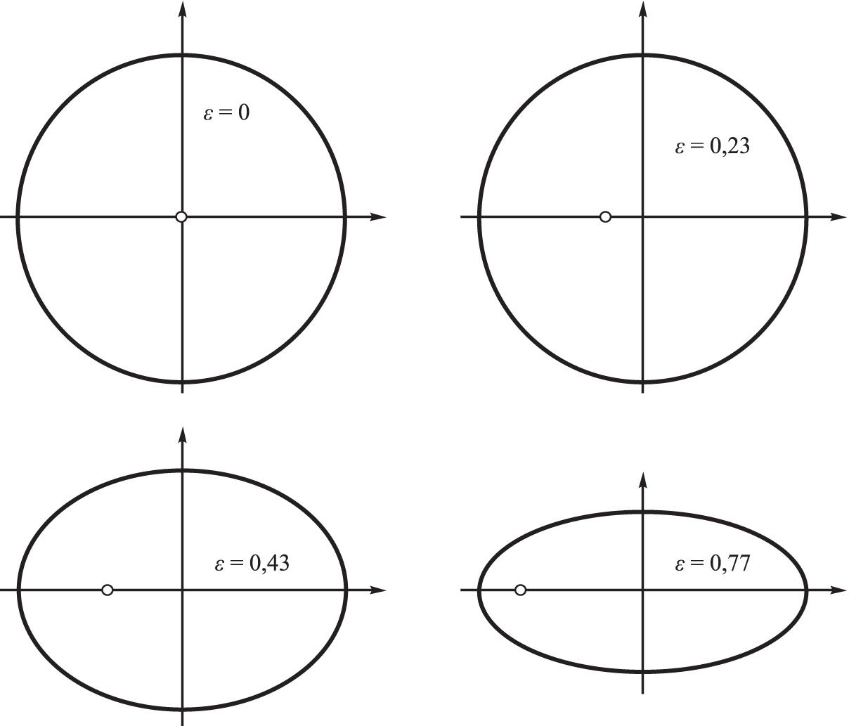
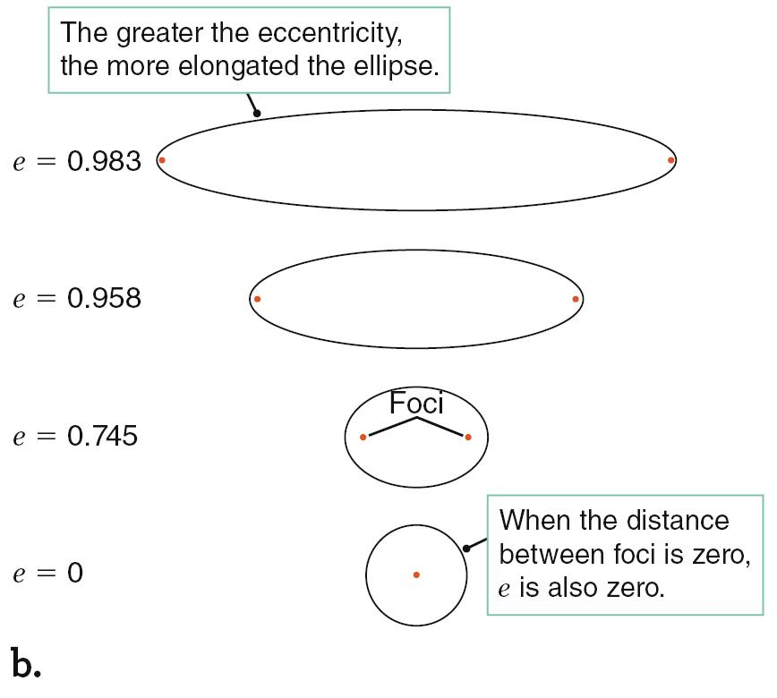
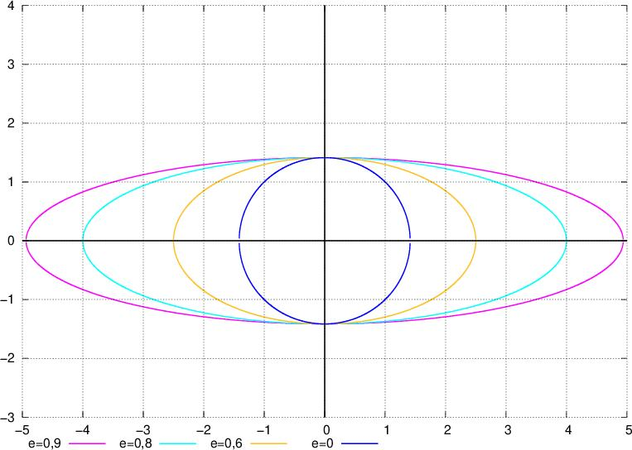

Elliptical Closed vs. Circular Closed Shapes
# Source: AI Source: Provided by: [Data Path: Persons Table -> ID Column: 1, Name_En Column: Motasem Essam] -> From: [ChatGPT] on [7/25/2026]
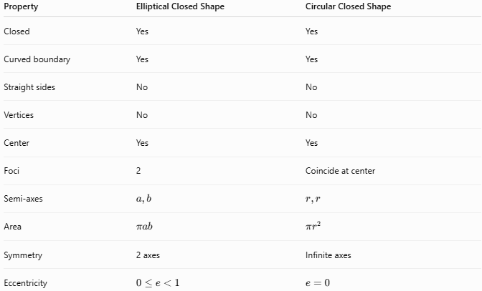
Property | Elliptical Closed Shape | Circular Closed Shape
Closed | Yes | Yes
Curved boundary | Yes | Yes
Straight sides | No | No
Vertices | No | No
Center | Yes | Yes
Foci | 2 | Coincide at center
Semi-axes | $$a,b$$ | $$r,r$$
Area | $$πab$$ | $$πr^{2}$$
Symmetry | 2 axes | Infinite axes
Eccentricity | $$0≤e<1$$ | $$e=0$$

Elliptical Closed vs. Irregular Closed Curves
# Source: AI Source: Provided by: [Data Path: Persons Table -> ID Column: 1, Name_En Column: Motasem Essam] -> From: [ChatGPT] on [7/25/2026]
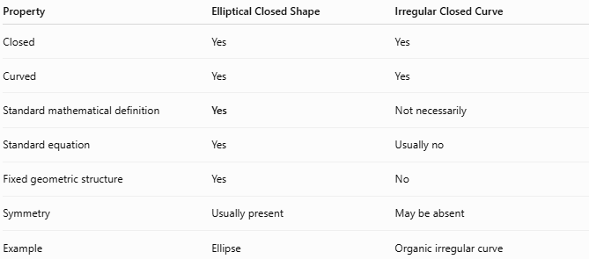
Property | Elliptical Closed Shape | Irregular Closed Curve
Closed | Yes | Yes
Curved | Yes | Yes
Standard mathematical definition | Yes | Not necessarily
Standard equation | Yes | Usually no
Fixed geometric structure | Yes | No
Symmetry | Usually present | May be absent
Example | Ellipse | Organic irregular curve
The key distinction is:
$$\boxed{\text{Ellipse}=\text{specific mathematical curve}}$$
while:
$$\boxed{\text{Irregular Closed Curve}=\text{arbitrary closed curved boundary}}$$

Key Points
# Source: AI Source: Provided by: [Data Path: Persons Table -> ID Column: 1, Name_En Column: Motasem Essam] -> From: [ChatGPT] on [7/25/2026]
An Elliptical Closed Shape has:
$$\boxed{\text{Closed}+\text{Curved}+\text{Elliptical Geometry}}$$
Its defining properties include:
- Two semi-axes $a$ and $b$.
- Two foci.
- No vertices.
- A closed continuous boundary.
- Two perpendicular axes of symmetry.
- ${180}^{∘}$ rotational symmetry.
- Area $A=πab$.
- Eccentricity $0≤e<1$.

Conclusion
# Source: AI Source: Provided by: [Data Path: Persons Table -> ID Column: 1, Name_En Column: Motasem Essam] -> From: [ChatGPT] on [7/25/2026]
Elliptical Closed Shapes are closed curved shapes whose boundaries follow the mathematical geometry of an ellipse. They include standard, horizontal, vertical, rotated, elongated, and concentric elliptical forms, as well as elliptical rings. The circle is a special case of an ellipse where the two semi-axes are equal. Elliptical shapes are therefore distinct from arbitrary irregular closed curves because their geometry follows a precise mathematical definition.

